
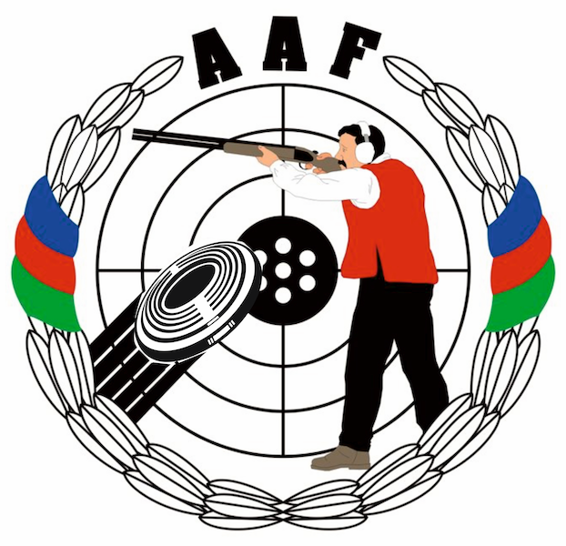
HEYDAR ALIYEV
INTERNATIONAL GRAND PRIX
Gabala, Azerbaijan
14 – 21 August 2014

Please email to Organizing Committee: info@gabala.eu
FINAL TRAVEL FORM |  |  |  | Please return by |  |  |  | to Organizing Committee
name of federation |  |  |  | 15 JULY 2014 |  |  |  | Lermontov str. 68  Baku, AZ1066, Azerbaijan  Phone: +994-50-5141515  Phone: +994-55-7537775  E-mail: info@gabala.eu
1. travel information
arrival |  |  |  |  |  |  | departure
airport | rail | car |  |  |  |  | airport |  | rail | car
date |  |  |  |  |  |  | date
time |  |  |  |  |  |  | time
flight no. |  |  |  |  |  |  | flight no.
from (airport) |  |  |  |  |  |  | from (airport)
no. of persons |  |  |  |  |  |  | no. of persons
2. eventual travel information
arrival |  |  |  |  |  |  | departure
airport | rail |  | car |  |  |  | airport |  | rail | car
date |  |  |  |  |  |  | date
time |  |  |  |  |  |  | time
flight no. |  |  |  |  |  |  | flight no.
from (airport) |  |  |  |  |  |  | from (airport)
no. of persons |  |  |  |  |  |  | no. of persons
3. eventual travel information
arrival |  |  |  |  |  |  | departure
airport | rail |  | car |  |  |  | airport |  | rail | car
date |  |  |  |  |  |  | date
time |  |  |  |  |  |  | time
flight no. |  |  |  |  |  |  | flight no.
from (airport) |  |  |  |  |  |  | from (airport)
no. of persons |  |  |  |  |  |  | no. of persons

